*Name: Jyothchandra Gude*

*Email: jyothchandragude@gmail.com*

**Credit Card Fraud Detection**

The dataset which we have used in this project is a collection of different transactions in a particular sample of two days and the attributes include ‘Time’, ‘V1-V28’, ‘Amount’ and ‘Class’. The ‘V1-V28’ are the results of PCA Transformation. The attribute Time and Amount are the time between the transaction and the first transaction and the attribute Amount is the transacted amount. The attribute Class is the one which has the value as 1 if the case is fraud and 0 otherwise. In this data set we have 492 fraud cases out of 2,84,807 transactions.

Exploratory data analysis:

A heatmap is generated for the taken data set which shows the data visualization.

In this approach to **data analysis** that uses a variety of techniques, largely visual, to: Maximize insight, reveal underlying structure, check for outliers, test assumptions, and determine optimal factors

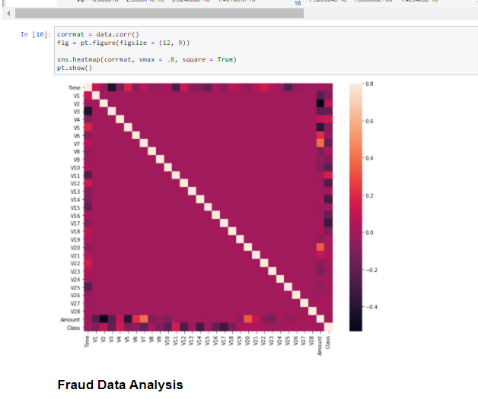

Questions On Dataset

1. **Find the number of fraudulent cases and Display the details?**

Answer:

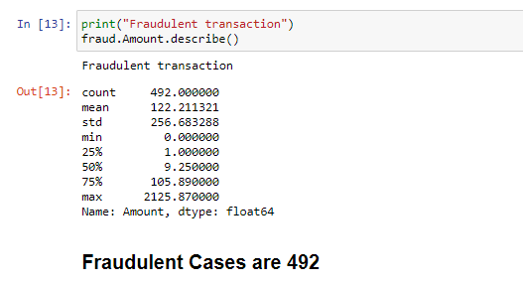

1. **Find the number of non-fraudulent cases and Display the details?**

Answer:

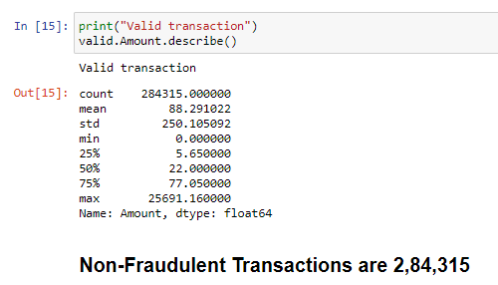

Ensemble Machine learning Modelling (3 Classification Algorithms)

1. Random Forest
2. Logistic Regression
3. Decision Tree

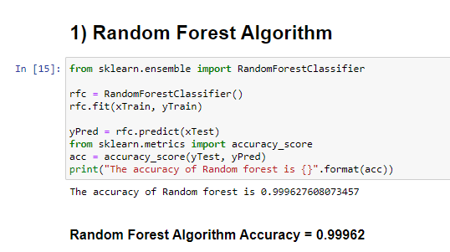

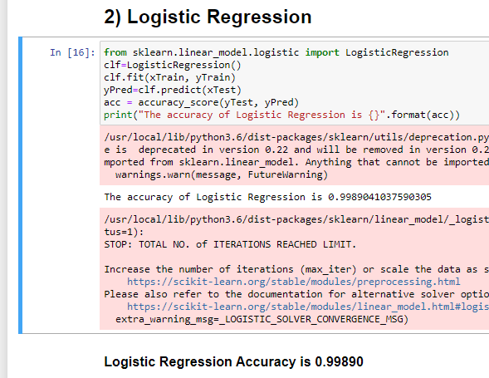

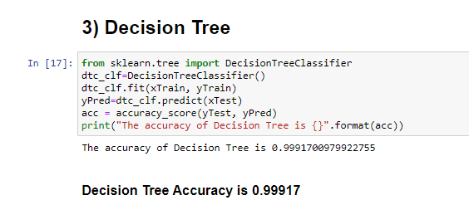

**Summary:**

Therefore after examining the results of the models **Random Forest Algorithm** gives better accuracy when compared to the other two algorithms with **99.96%** which is way accurate than other two models.